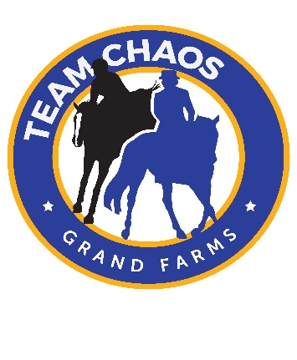
ACG Equestrian @ Grand Farms
17616 S. Vaughn Rd KpN PO Box 928
Vaughn WA 98394 (253)225-3672
Release of Liability
I, the undersigned participant, hereby acknowledge and agree to release and hold Grand Farms, ACG Equestrian and all the persons, firms and corporations associated therewith including, but not limited to, the employees of Grand Farms fully harmless from any injury, claim, legal fees or damage (personal or property) whatsoever, including death, which may result to me, my horse(s), or any of my property, as a consequence of boarding or participating in any riding, training, or other equestrian activities occurring on or off the premises operated by Grand Farms (hereafter known as “the premises” located at 17616 S. Vaughn rd NW, Vaughn Washington, including but not limited to the stables, pastures, riding areas and barns)
I, the undersigned participant, acknowledge and agree that riding or related equestrian activities are inherently dangerous and I agree to fully assume the risk, chance, hazard and responsibility associated with an riding or related equestrian activities conducted on or of the premises. I voluntarily enter the premises, fully aware of potential risks. I hereby voluntarily assume all risks and agree that this release shall be binding upon my heirs, executors, administrators or spouse.
I, the undersigned participant, acknowledge and agree that I have had the complete opportunity to inspect and review the premises including, but not limited to, the current condition of the riding areas, barn, stable, fences, pastures, trails, and surrounding property.
I, the undersigned participant, acknowledge and agree the Grand Farms and ACG Equestrian, employees, and others associated with the facility are not responsible for any damaged, lost, or missing tack or personal belongings.
In the event that the participant is a minor, the signing of this release by the parent (s) or the legal guardian of the participant shall release Grand Farms and ACG Equestrian, the employees, and others associated with these organizations from any claims, demands or legal fees of any kind arising from any loss, injury, or death sustained by the parent, guardian, participant or guests thereof, including but not limited to all the risks described above, which may occur on or off the premises. I give myself of the minor participant on behalf of whom I am signing permission to board and/or ride at the premises with training/instruction provided by Grand Farms, ACG Equestrian and/or its employees and to participate in any activities at the premises.
THE UNDERSIGNED ACKNOWLEDGES THAT HE/SHE HAS READ THIS ENTIRE HOLD HARMLESS AND RELEASE OF LIABILITY AND FULLY UNDERSTANDS IT. THE UNDERSIGNED FURTHER ACKNOWLEDGES THAT HE/SHE IS EIGHTEEN (18) YEARS OF AGE OR OLDER, OR THAT HE/SHE IS FULLY AUTHORIZED PARENT OR GAURDIAN OF THE MINOR CHILD ON BEHALF OF WHOM HE/SHE IS SIGNING.
Signature of participant__________________________________________Age________Date:
Parents Signature:_________________________________________Date_________________
(parent or legal guardian MUST sign for the child under eighteen years of age)
Phone Number_______________________________________________

