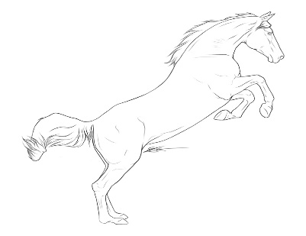
Rolling Ridge Farm

Lainey Ashker Clinic
Jan. 14-15 2017
Participant Name:__________________________________

Horse Name: ______________________________________

Auditor: _____ Participant:_______

Stabling: _______

Total enclosed: _________

(clinic fee $350, auditors $35 per day or $65 for the weekend)

