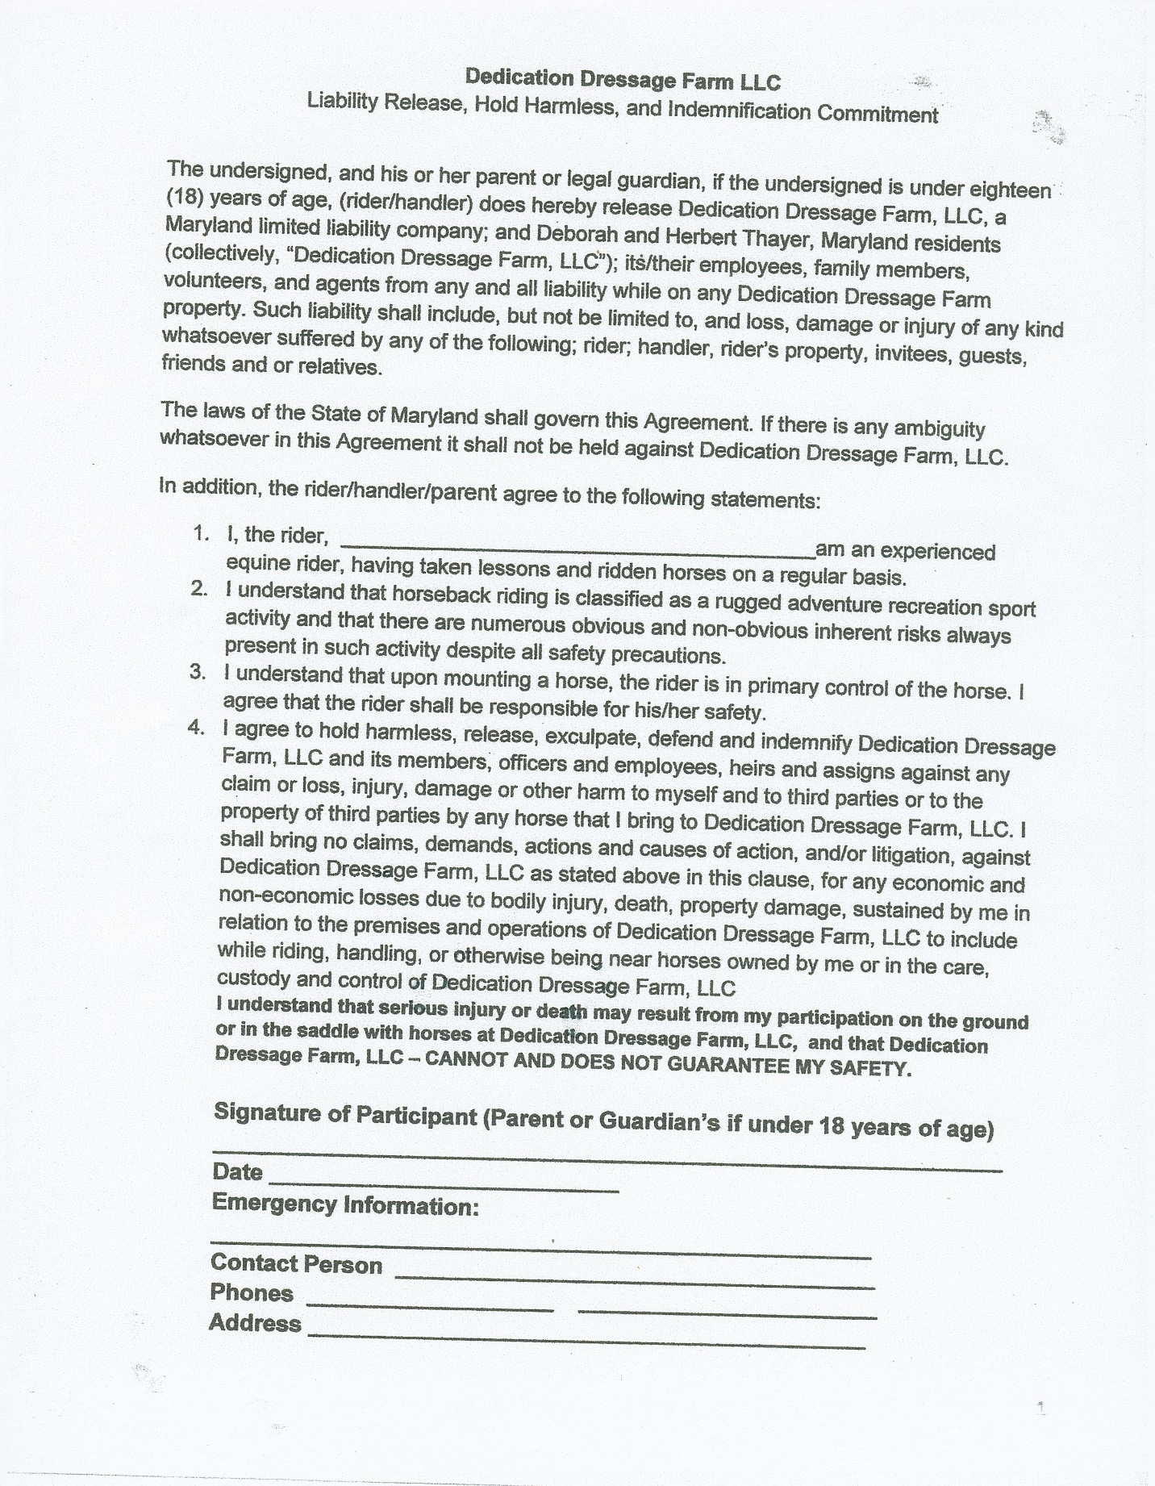
Other Information:
Name of Horse’s boarding Facility: ___________________________________
Address: ________________________________________________________

